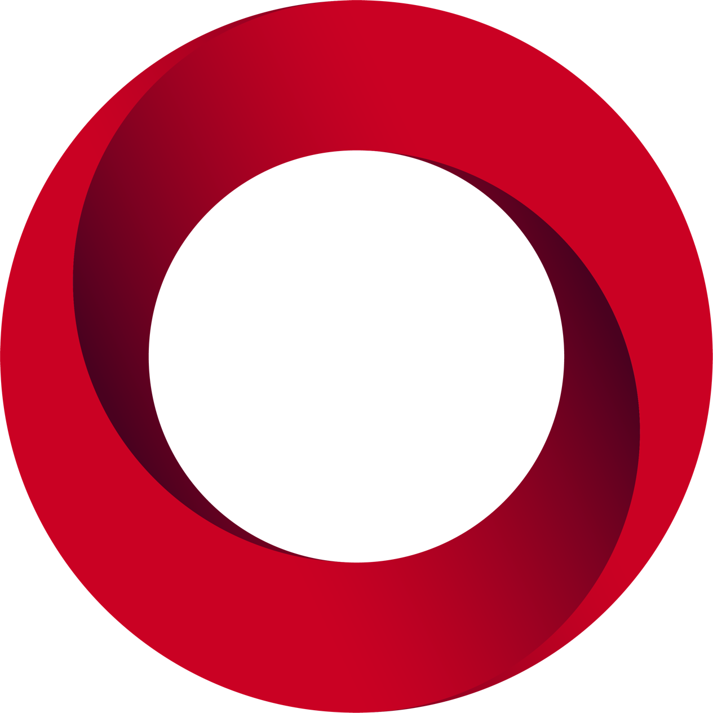
4
UL-US-L486238-11-10100202-1
E486238-20171116

Certificate of
Compliance

 |  | Issued to:
Certificate Number:  UL-US-L486238-11-10100202-1  Report Reference:  E486238-20171116  Issue Date:  2024-04-05 |  | Hanza Assembly Zabreh, s.r.o.  Obornik 31 Zabreh 789 01  Czech Republic  This certificate confirms that representative samples of:  NITW - Industrial Control Panels  See Addendum Page for Product Designation(s).  Have been evaluated by UL in accordance with the Standard(s) indicated on this Certificate.  UL 508A, 2nd edition, Rev. 2017-07-31  Additional Information:  See UL Product iQ® at https://iq.ulprospector.com for additional information.
This Certificate of Compliance indicates that representative samples of the product described in the certification report have met the requirements for UL certification. It does not provide authorization to apply the UL Mark. Only the Authorization Page that references the Follow-Up Services Procedure for ongoing surveillance provides authorization to apply the UL Mark.

Only those products bearing the UL Mark should be considered as being UL Certified and covered under UL’s Follow-Up Services.

Look for the UL Certification Mark on the product. 1

This is to certify that representative samples of the product as specified on this certificate were tested according to the current UL requirements.
Model | Product Description
Industrial control panels | Industrial Control Panels

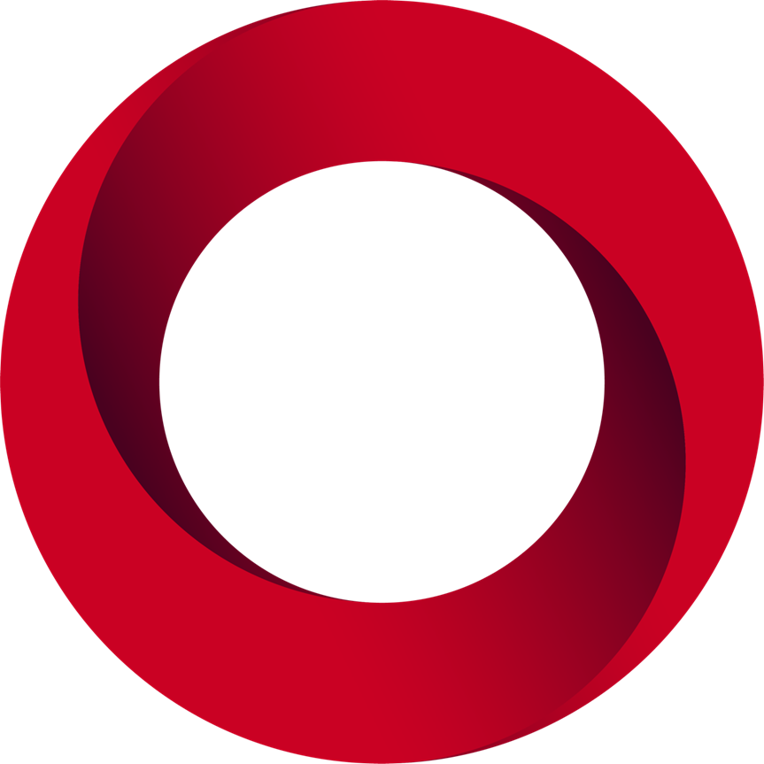
4
UL-CA-L486238-21-10100202-1
E486238-20171116

Certificate of
Compliance

 |  | Issued to:
Certificate Number:  UL-CA-L486238-21-10100202-1  Report Reference:  E486238-20171116  Issue Date:  2024-04-05 |  | Hanza Assembly Zabreh, s.r.o.  Obornik 31 Zabreh 789 01  Czech Republic  This certificate confirms that representative samples of:  NITW7 - Industrial Control Panels Certified for Canada  See Addendum Page for Product Designation(s).  Have been evaluated by UL in accordance with the Standard(s) indicated on this Certificate.  CSA 22.2 No. 14-13, March 2013  Additional Information:  See UL Product iQ® at https://iq.ulprospector.com for additional information.
This Certificate of Compliance indicates that representative samples of the product described in the certification report have met the requirements for UL certification. It does not provide authorization to apply the UL Mark. Only the Authorization Page that references the Follow-Up Services Procedure for ongoing surveillance provides authorization to apply the UL Mark.

Only those products bearing the UL Mark should be considered as being UL Certified and covered under UL’s Follow-Up Services.

Look for the UL Certification Mark on the product. 1

This is to certify that representative samples of the product as specified on this certificate were tested according to the current UL requirements.
Model | Product Description
Industrial control panels | Industrial Control Panels

